Safety Data Sheet Issue date: 05/24/13
Product: PCT 6101, B, D, P, and T Revisions: 10/12/17

Issued to conform to 29 CFR 1910.120 (2012), ANSI Z400.5, and GHS

Section 1 - Identification
a) Product Label: PCT 6101, 6101 B, 6101 D, 6101 P, and 6101 T
b) Other identification: water treatment compound
c) Uses: corrosion and scale inhibitor for closed loop water systems
d) Manufacturer: ProChemTech International, Inc.
51 ProChemTech Drive, PO Box 214
Brockway, PA 15824
e) Emergency Phone: 800-255-3924 Information Phone: 814-265-0959
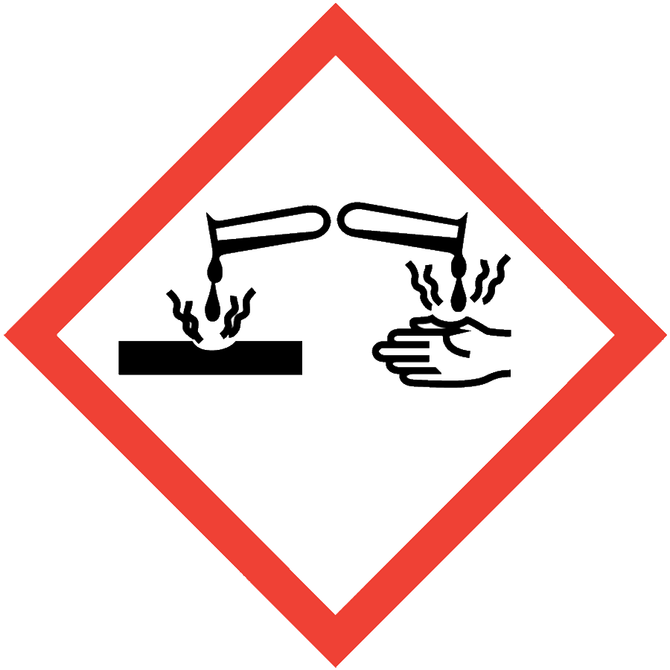
Section 2 - Hazard Identification Signal word: Danger
a) Hazard classification: corrosive
b) Signal word: danger
Hazard statement: causes severe skin burns and eye damage
Precautionary statements:
wear chemical goggles, body covering clothing, and gloves when handling neat product
avoid contact with skin and eyes
store in secure area
c) Other hazards: strong oxidizer
d) Untested ingredients over 1%: none

Section 3 - Composition/information on ingredients that are health hazards
ingredient CAS % by weight
a) sodium hydroxide 1310-73-2 < 3%

Section 4 - First aid measures
a) 1. Inhalation: remove to fresh air, seek immediate medical attention
2. Ingestion: Rinse mouth. Do not induce vomiting. Give several glasses of milk or water to drink to dilute. Seek immediate medical attention.
3. Skin contact: remove any contaminated clothing, wash skin with soap and water for at least
15 minutes. Get medical attention if irritation develops or persists
4. Eye contact: immediately flush eyes with plenty of water for at least 15 minutes, lifting
upper and lower lids occasionally. Remove contact lenses if present and easy to do. Seek
immediate medical attention.
b) Most important symptoms: soapy feeling followed by severe irritation and burning sensation

c) Special treatment if needed: There is no specific antidote. Treatment of overexposure should be directed at the control of symptoms and the clinical condition of the patent. Any material aspirated during vomiting may cause lung injury. Therefore, emesis should not be induced mechanically or pharmacologically. If it is considered necessary to evacuate stomach contents, this should be done by means least likely to cause aspiration.

Section 5 - Fire fighting measures
a) Suitable and unsuitable extinguishing media: none, non-flammable
b) Specific hazards from combustion products: carbon dioxide and monoxide and various nitrogen compounds may be produced. Note that dried product is a strong oxidizer - nitrite.

Section 6 - Accidental release measures
a) 1. Personal precautions: spilled product is a slip hazard
2. Protective equipment: rubber boots, chemical goggles, and gloves
3. Emergency procedures: secure area of spill or leak. In the event of a fire, wear full protective clothing and NIOSH approved self contained breathing apparatus with full facepiece operated in pressure demand mode.
b) Methods and materials for containment and cleaning
1. Stop spill or leak at source. Contain spilled material by dikes using any convenient non-flammable material such as earth or dry sand.
2. Contain and recover liquid when possible by vacuum, mop, or similar method of liquid
pickup.
3. Liquid can be diked/contained and absorbed with inert materials such as vermiculite, dry
sand, earth, cat litter, saw dust or similar material. Please note that dried product is a strong oxidizer. Following pickup of free liquids, spill areas can be flushed with fresh water and rinsate discharged to sanitary sewer. Check regulations for pH of discharge and neutralize dilute rinsate only with citric acid if required. Do not add acid to product under any circumstances as gaseous nitrogen oxides will be produced. Do not discharge to stream.

Section 7 - Handling and storage
a) Protect containers from physical damage. Store in secure, cool, dry, area away from low pH materials. Dried product is a strong oxidizer and will react with reducers, acids, wood , organic materials, and many metals.

Section 8 - Exposure controls/personal protection
a) ACGIH Exposure Level: TLV = 2 mg/m3 (sodium hydroxide)
b) Engineering controls: A system of local or general exhaust is recommended to keep employee exposures below airborne exposure limits. Local exhaust is generally preferred because it can control emissions of the contaminant at its source.
c) Personal protection equipment: Wear chemical goggles, protective gloves and clean, body covering clothing when working with neat product. Eye wash fountain and quick drench facilities should be maintained in work area.
Section 9 - Physical and chemical properties
a) Appearance: 6101, 6101 D, and 6101 T clear liquid, 6101 B blue liquid, 6101 P pink liquid
b) Odor: faint azole
c) Odor threshold: not determined
d) pH: 12.6-13.0
e) Melting/freezing point: 32 F
f) Initial boiling point: not determined
g) Flash point: none
h) Evaporation rate: water
i) Flammability: no
j) Flammability limits: none, non-flammable
k) Vapor pressure: water
l) Vapor density: water
m) Relative density: 10.9 - 11.3 lb/gallon
n) Solubility: 100% in water
o) Partition coefficient n-octanol/water: not determined
p) Auto ignition temperature: none
q) Decomposition temperature: not determined
r) Viscosity: not determined

Section 10 - Stability and reactivity
a) Reactivity: non-reactive under ordinary conditions of use and storage
b) Chemical stability: stable under ordinary conditions of use and storage
c) Possibility of hazardous reactions: none under ordinary conditions of use and storage
d) Conditions to avoid: high temperatures, mixture with strong acids, organics, and reducing agents
e) Incompatible materials: strong acids, reducing agents, organics, and reactive metals such as aluminum and zinc.
f) Hazardous decomposition products: carbon dioxide and monoxide, and various nitrogen compounds may form when heated to decomposition or by partial combustion. Reaction with reactive metals can produce highly flammable/explosive hydrogen gas.

Section 11 - Toxicological information
a) Likely routes of exposure:
1. Inhalation: acute hazard
2. Ingestion: acute hazard
3. Skin contact: acute hazard
4. Eye contact: acute hazard

b) Related symptoms:
1. Inhalation: severe irritation, burning sensation
2. Ingestion: severe irritation, burning sensation
3. Skin contact: irritation, burning sensation
4. Eye contact: severe irritation, burning sensation
c) Immediate, delayed, and chronic effects from short and long term exposure: short term corrosive, no delayed or chronic effects reported.
d) Toxicity data:
Oral rat LD 50: 2,491 mg/kg (product)
Skin rabbit MOD: not reported
Eye rabbit/Draize:
e) NTP and IRAC listings: NTP known - no; anticipated - no
IARC category - none

Section 12 - Ecological information
a) Ecotoxicity data:
rainbow trout 96 hr static LC 50:
sheepshead minnow 96 hr static LC 50:
daphnia magna 48 hr static LC 50:
b) Persistence and degradability: Readily degrades with release to soil and water.
c) Bioaccumulative potential: none
d) Mobility in soil: will leach into ground water

Section 13 - Disposal considerations
Preferred method of disposal is recovery and/or recycling. Small quantities may be diluted and discharged to sanitary sewer, Note product has a high pH and is a strong oxidizer. Rinse containers three times before recycle or disposal. Consult specific federal, state and local requirements and regulations as substantial differences may exist as to product and container disposal.

Section 14 - Transport information
a) UN number: UN 1824
b) UN proper shipping name: sodium hydroxide solution
c) Transport hazard class(es): 8, corrosive
d) Packing group: III
e) Environmental hazards: high pH, strong oxidizer product
f) Transport in bulk: no regulation
g) Special precautions: none found

Section 15 - Regulatory information
a) TSCA: all components registered
b) SARA 302 EHS: no
c) SARA 313 listed: yes
d) CERCLA reporting: yes
e) RCRA 261.33 regulated: no
f) NFPA ratings:
1. Health - 1
2. Flammability - 0
3. Reactivity - 1
g)

Section 16 - Date of preparation, last revision
a) Issue date: 05/24/13
b) Last revisions 10/16/13

